**Seven segment display interfacing**

There are eight 7 segment displays present on the development board. The data lines for all of them are *common (P00 to P07)*, *therefore we have to use multiplexing to use them all simultaneously*.

A single display can be turned ON/OFF using LED1-LED8 signals. To save pins LED1-LED8 signals are provided through a 3- to 8-Line decoder which means that three pins from the microcontroller can control 8 signals (LED1 to LED8) as shown in the following figure.

|  |
| --- |
|  |

|  |
| --- |
| C:\Users\lenovo\AppData\Local\Packages\Microsoft.Windows.Photos_8wekyb3d8bbwe\TempState\ShareServiceTempFolder\Screenshot (19).jpeg |

|  |  |  |  |
| --- | --- | --- | --- |
| C:\Users\lenovo\AppData\Local\Packages\Microsoft.Windows.Photos_8wekyb3d8bbwe\TempState\ShareServiceTempFolder\Screenshot (22).jpeg | C:\Users\lenovo\AppData\Local\Packages\Microsoft.Windows.Photos_8wekyb3d8bbwe\TempState\ShareServiceTempFolder\Screenshot (23).jpeg | C:\Users\lenovo\AppData\Local\Packages\Microsoft.Windows.Photos_8wekyb3d8bbwe\TempState\ShareServiceTempFolder\Screenshot (27).jpeg | C:\Users\lenovo\AppData\Local\Packages\Microsoft.Windows.Photos_8wekyb3d8bbwe\TempState\ShareServiceTempFolder\Screenshot (28).jpeg |
| C:\Users\lenovo\AppData\Local\Packages\Microsoft.Windows.Photos_8wekyb3d8bbwe\TempState\ShareServiceTempFolder\Screenshot (29).jpeg | C:\Users\lenovo\AppData\Local\Packages\Microsoft.Windows.Photos_8wekyb3d8bbwe\TempState\ShareServiceTempFolder\Screenshot (30).jpeg |  | C:\Users\lenovo\AppData\Local\Packages\Microsoft.Windows.Photos_8wekyb3d8bbwe\TempState\ShareServiceTempFolder\Screenshot (31).jpeg |

**What Is The Purpose Of Using `74HC245` With 7 Segment Displays:**

**(**Studying the datasheet of 74HC245**)**

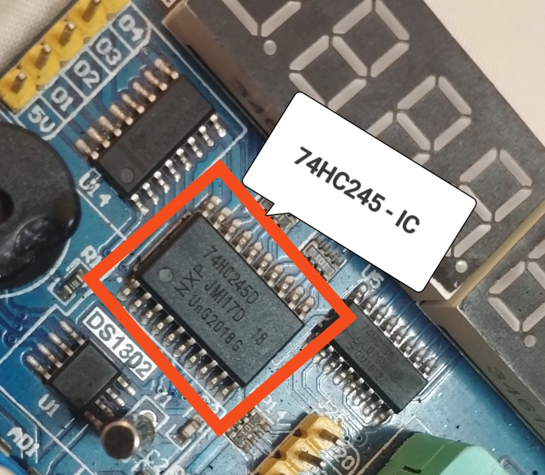

|  |
| --- |
|  |

* The *74HC245 is an octal bus transceiver IC (integrated circuit)* which is commonly used in digital electronic circuits.
* Its main purpose is *to enable bidirectional data transfer between two data buses*, making it useful for various applications including *interfacing between different parts of a digital system.*
* When using a 7-segment display with a 74HC245, the purpose is typically to *interface between the microcontroller or digital logic circuit generating the segment data and the display itself*.
* The *7-segment display requires specific patterns of data to be presented* to it in order to display numerals or other characters. The 74HC245 can help facilitate this by providing a way to *transfer the data from the microcontroller or logic circuit to the display.*

Here's how the 74HC245 might be used with a 7-segment display:

**Data Transfer:** The microcontroller or logic circuit outputs the segment data (binary or hexadecimal) corresponding to the digit to be displayed.

**Direction Control:** The direction control pins of the 74HC245 are set to control the direction of data flow. For instance, if the microcontroller is outputting data to the display, the direction control pins would be set to allow data to flow from the microcontroller to the display.

**Buffering:** The segment data lines from the microcontroller are connected to the input side of the 74HC245. The output side of the 74HC245 is connected to the input pins of the 7-segment display.

**Data Output:** Once the direction is set correctly, the 74HC245 transfers the data from the microcontroller to the 7-segment display.

**Display Update:** The 7-segment display updates its segments based on the data received from the 74HC245, thereby displaying the desired digit or character.

*By using the 74HC245, you can isolate the microcontroller from the current requirements of the 7-segment display and also facilitate bidirectional data transfer, making the interfacing process more efficient and reliable.*

**What Is The Purpose Of Using `74HC138` With 7 Segment Displays:**

**(**Studying the datasheet of 74HC138D {D-> Decoder} **)**

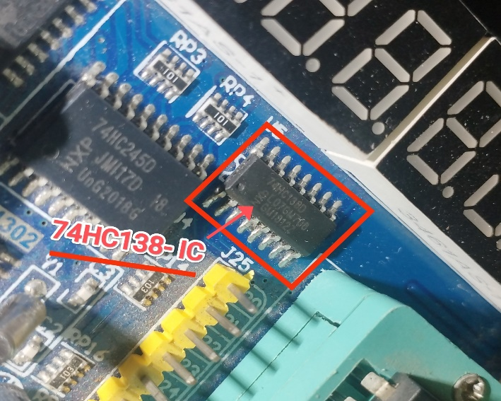

|  |
| --- |
|  |

* The *74HC138 is a 3-to-8 line decoder/demultiplexer IC*, commonly used in digital electronic circuits.
* Its *main purpose is to convert binary information (received as input) into one of eight output lines based on the specific combination of inputs.* This makes it useful for various applications where decoding of binary data into multiple output signals is required.

When using a 74HC138 with a 7-segment display, the purpose is typically to simplify the control of multiple displays or to enable the multiplexing of several displays with a limited number of microcontroller pins. Here's how the 74HC138 might be used with a 7-segment display:

**Reducing Control Pins:** Instead of using individual control pins from the microcontroller to select each 7-segment display, the 74HC138 can be used to decode a binary signal into one of eight output lines, reducing the number of control pins required.

**Driving Multiplexed Displays**: In a multiplexed display setup, where multiple displays are driven sequentially, the 74HC138 can help in selecting which display to activate at a given time.

**Addressing Specific Display**: Each 7-segment display might be assigned a unique address (binary combination). The 74HC138 decodes this address and selects the corresponding display to receive data from the microcontroller.

**Simplifying Control Logic**: The microcontroller sends a binary signal representing the desired display to the 74HC138. The 74HC138 then activates the appropriate output line based on this signal, simplifying the control logic needed in the microcontroller.

**Enabling Multiplexing:** By selecting different outputs of the 74HC138 at different times, multiple 7-segment displays can share the same set of data lines, enabling multiplexing to display different digits or characters sequentially.

*In summary, the 74HC138 simplifies the process of controlling multiple 7-segment displays by decoding binary signals from the microcontroller and selecting the appropriate display to receive data or be activated. It helps reduce the number of control pins required and facilitates multiplexing of displays.*

**There Are Two Types Of 7-Segment Display(Common Anode Or Common Cathode):**

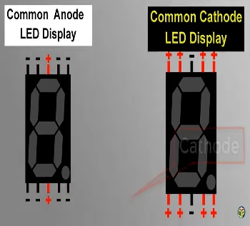

*Certainly! Let's delve deeper into the context of anodes and cathodes in the context of the 74HC245 and how they affect the blinking of LEDs in a 7-segment display.*

***1. Understanding the Context:***

*- In the context of the 74HC245, anodes and cathodes typically refer to the terminals of the LEDs within a 7-segment display.*

*- A 7-segment display comprises multiple LEDs arranged in a specific pattern to represent numbers from 0 to 9 and sometimes letters.*

***2.******Anode and Cathode in 7-Segment Display:***

*- Each LED within a 7-segment display has two terminals: an anode (positive terminal) and a cathode (negative terminal).*

*- Depending on the type of 7-segment display (common anode or common cathode), either all the anodes or all the cathodes of the LEDs in a segment are connected together internally.*

***3. Common Anode vs. Common Cathode:***

*- In a common anode 7-segment display, all the anodes of the LEDs in each segment are connected together and brought out as a single pin.*

*- In a common cathode 7-segment display, all the cathodes of the LEDs in each segment are connected together and brought out as a single pin.*

***4. Effect on LED Blinking:***

*- When controlling the blinking of LEDs in a 7-segment display using a microcontroller or digital circuitry, the choice of common anode or common cathode affects how the LEDs are controlled.*

*- In a common anode display, applying a high voltage (logic 1) to the common anode pin while grounding the cathode pins of the desired segments will light up those segments.*

*- In a common cathode display, applying a low voltage (logic 0) to the common cathode pin while supplying voltage to the anode pins of the desired segments will light up those segments.*

***5. Blinking Mechanism:***

*- To make the LEDs blink, the microcontroller or digital circuitry alternates between applying the necessary voltage (high or low) to the common pin and the segment pins.*

*- By rapidly switching between these states, the LEDs are turned on and off in a controlled manner, creating the blinking effect.*

***6. Considerations for Blinking:***

*- When designing a blinking pattern for a 7-segment display, the timing of the on and off states for each segment must be carefully controlled to achieve the desired visual effect.*

*- The choice of common anode or common cathode determines the logic levels required to control the LEDs, influencing the programming or circuit design.*

*In**summary, in the context of the 74HC245 and 7-segment displays, anodes and cathodes refer to the terminals of the LEDs within the display. The choice of common anode or common cathode affects how the LEDs are controlled, which, in turn, influences the blinking pattern created by the microcontroller or digital circuitry.*